Assignment 01

Write a C# console program that prints the following patterns separately, one below the other. Use for loops to generate the patterns.

Method of submission: online submission of source code and output screenshot

(A)
using System;
using System.Collections.Generic;
using System.Linq;
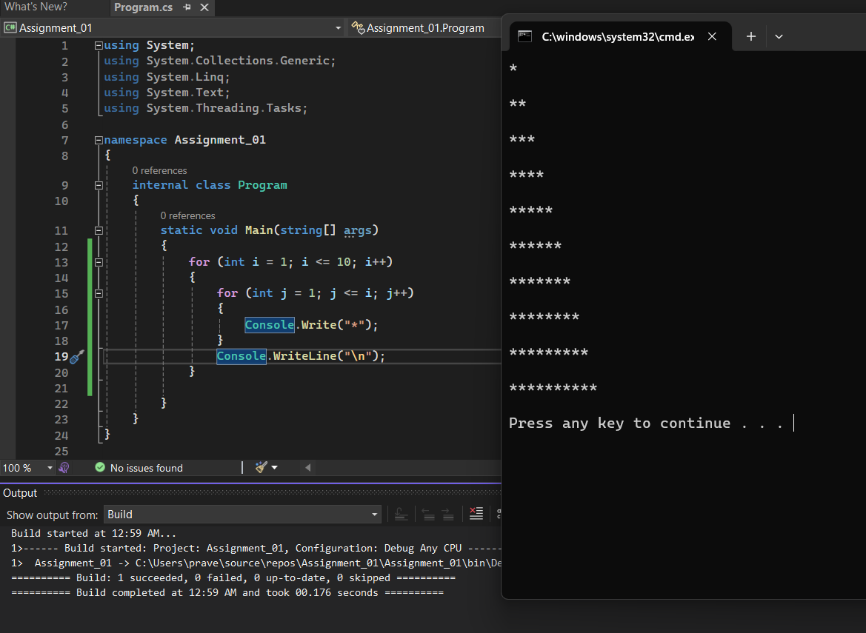
using System.Text;
using System.Threading.Tasks;

namespace Assignment_01
{
internal class Program
{
static void Main(string[] args)
{
for (int i = 1; i <= 10; i++)
{

for (int j = 1; j <= i; j++)
{
Console.Write("*");
}
Console.WriteLine("\n");

}

}
}

(B)
using System;
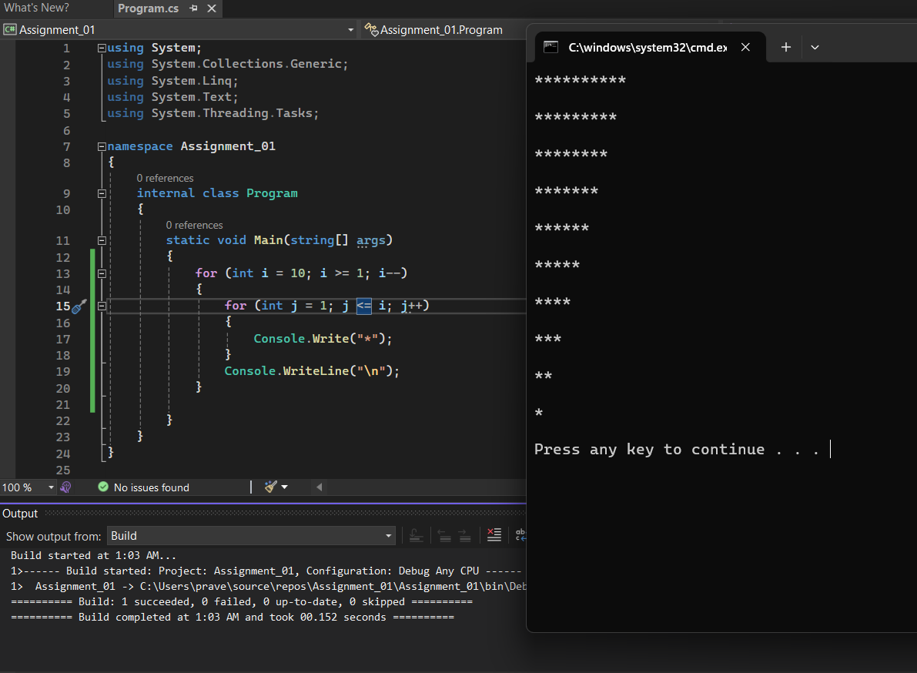
using System.Collections.Generic;
using System.Linq;
using System.Text;
using System.Threading.Tasks;

namespace Assignment_01
{
internal class Program
{
static void Main(string[] args)
{
for (int i = 10; i >= 1; i--)
{

for (int j = 1; j <= i; j++)
{
Console.Write("*");
}
Console.WriteLine("\n");

}

}
}
}

(C)
using System;
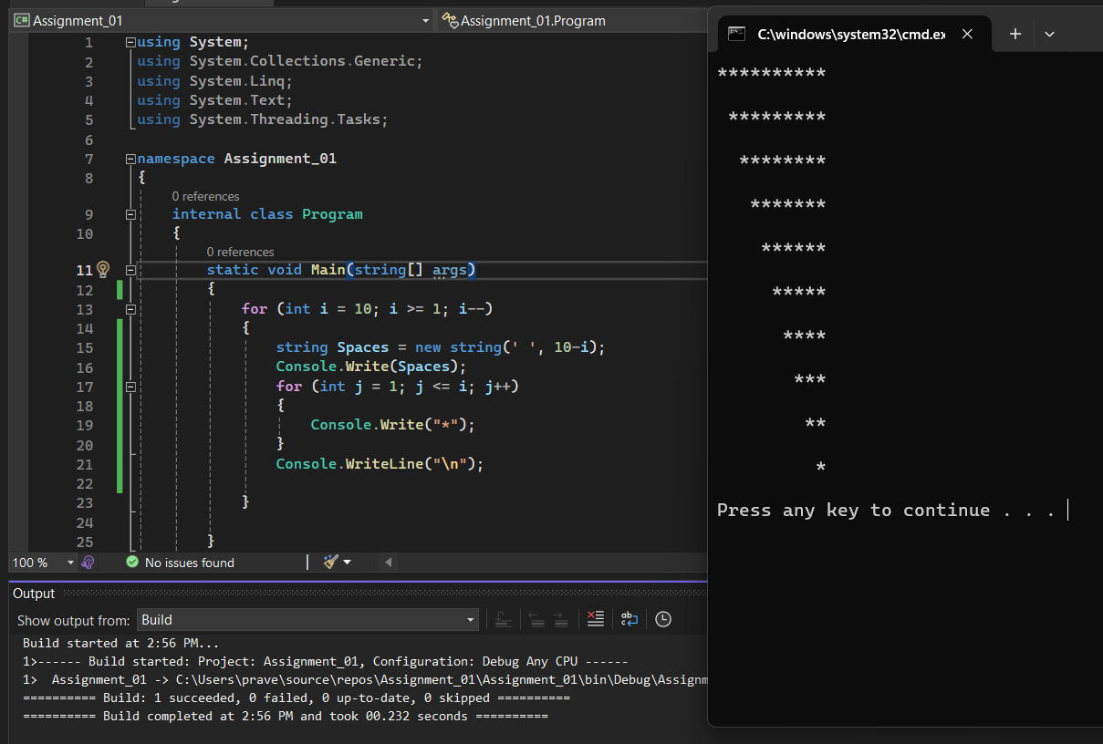
using System.Collections.Generic;
using System.Linq;
using System.Text;
using System.Threading.Tasks;

namespace Assignment_01
{
internal class Program
{
static void Main(string[] args)
{
for (int i = 10; i >= 1; i--)
{
string Spaces = new string(' ',10-i);
Console.Write(Spaces);
for (int j = 1; j <= i; j++)
{
Console.Write("*");
}
Console.WriteLine("\n”);
}
}
}
}
(D)

using System;
using System.Collections.Generic;
using System.Linq;
using System.Text;
using System.Threading.Tasks;

namespace Assignment_01
{
internal class Program
{
static void Main(string[] args)
{
for (int i = 1; i <= 10; i++)
{
string Spaces = new string(' ', 10-i);
Console.Write(Spaces);
for (int j = 1; j <= i; j++)
{
Console.Write("*");
}
Console.WriteLine("\n");

}

}
}
}

